**Personal Portfolio Template**

Group 44

Jahred Mauricio – n9740805

Github link: https://github.com/harry16686/5G1C-Developers

**Artefact 1** – Three-layer Client/Server Architecture – created with Harry Perkins

Description about what the artefact is in general

A Three-layer Client/Server Architecture is a type of Computer Architecture under the Model-View-Controller (MVC) pattern. It is used by software engineers to create a design by setting the rules and methods that describe the functionality of computer systems. This architecture pattern spreads the three computing layers, i.e. Presentation, Application and Database.

Brief description of how it was used/contribution to the project

Designing the three-layer client/service architecture design is part of the initial system development process. The three computing layers consist of the User Interface (UI), Web Server and the Database. During the architecture pattern design process, Harry and I listed down which elements belong in which layer, thus leading to the creation of the logical and physical iteration. A logical and physical design were then created to show an elaborated form of the web-based application. This helped the developers tick-off the requirements needed during the initial development stage of the website.

Screen capture of where it’s used

Refer to folder ‘1. Architecture Pattern’ for the three-layer pattern design.

**Artefact 2** – Component Diagram

Description about what the artefact is in general

A Component Diagram is a type of a Unified Modelling Language (UML). It shows the relationship of the different components in a system and depicts how components are ‘wired’ together.

Brief description of how it was used/contribution to the project

A Component Diagram (for an admin perspective) has been created for Sprint 1 that covers the components of what our target was in our Sprint 1 document. It was necessary to create one as it helps illustrate the structure of the web application. This will give an overview of the website and how the components are used to show its functionalities. As this is part of the initial development process, the team developers used the component diagram in the actual development stage which helped how the website was structured.

Screen capture of where it’s used

Refer to folder ‘2. Component Diagram’ for the component diagram.

**Artefact 3** – Business Process Model Notation (BPMN) – created with Wen Yang

Description about what the artefact is in general

A Business Process Model and Notation (BPMN) is a graphical representation; used to illustrate the processes of a business in a diagram form that share similar elements to a flowchart.

Brief description of how it was used/contribution to the project

2 BPMNs were constructed to show the developers the client’s business processes.

The first BPMN is a diagram showing the process of how the admin of the CRC would process the modification of a client’s booking. The second BPMN is a diagram that shows the core process of the business; i.e. the actual renting of a vehicle process. These illustrations helped the developers give an idea about how the website should function from a user’s perspective. Thus, helped gave an idea of how to structure and improve the system design.

Screen capture of where it’s used

Refer to folder ‘3. BPMN’ for images of the BPMN diagrams.

**Artefact 4** – Graphical User Interface – created with Harry Perkins

Description about what the artefact is in general

A Graphical User Interface (GUI) is the visual design that allows the user to interact with the computer system through graphical icons and visual indicators.

Brief description of how it was used/contribution to the project

User Interface prototyping was used during the initial development stage where iteration of mock ups were created to suit the team’s client’s preference. Low-fidelity GUI prototypes were first created through hand drawings and then medium-fidelity GUI prototypes were created using a software tool. The GUI mock up designs provided the developers a rough draft of how the website should look like in a user’s point of view.

Screen capture of where it’s used

Refer to folder ‘4. User Interfaces’ for images of the final iterations of the UI mock-ups.

**Artefact 5** – HTML – created with Wen Yang

Description about what the artefact is in general

Artefact 5 consist of the use of Hypertext Markup Language (HTML), which is generally used for creating web pages and web applications.

Brief description of how it was used/contribution to the project

HTML was used during the development stage of the web application in which I assisted the developers in constructing the website. Using the different HTML elements, we were able to develop the layout of the different web pages and structure them to try to make them look similar to the UI designs.

Screen capture of where it’s used

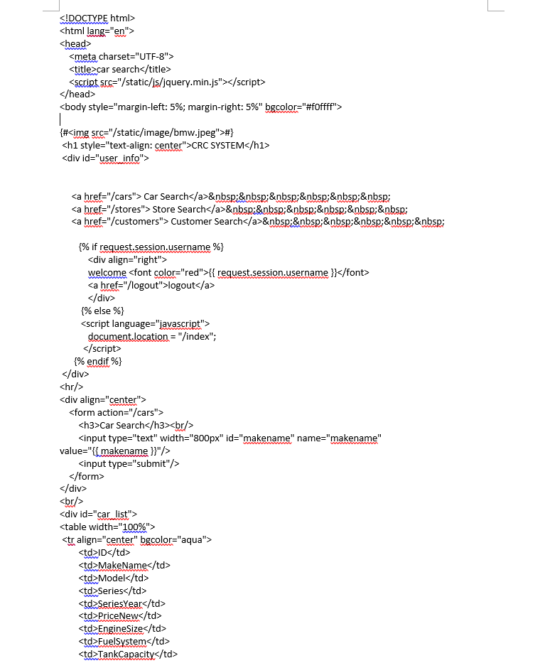Store Inventory code:

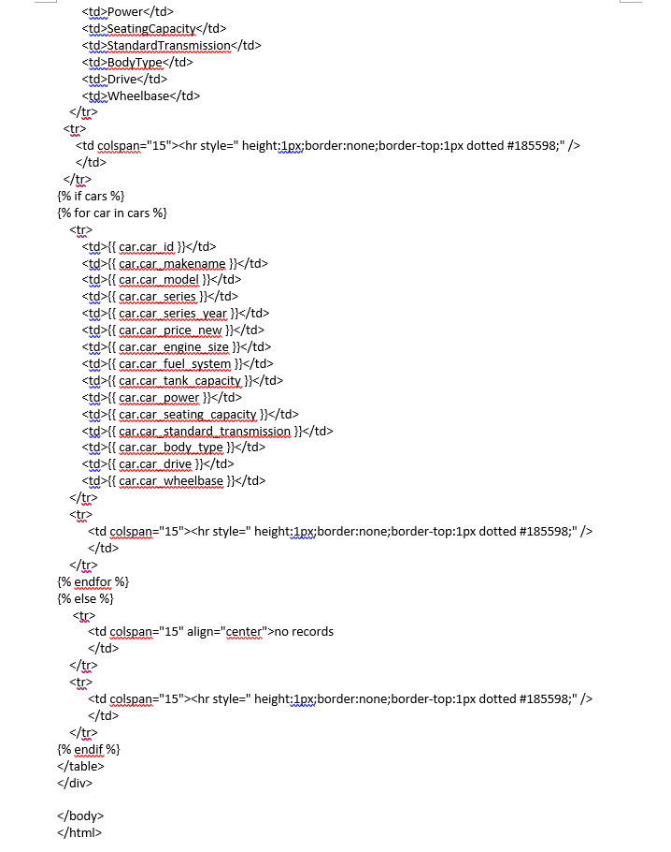

Store Location:

